**A**

**Mini Project Report**

**On**

**DETECTION OF CYBER HARASSERS ON SOCIAL MEDIA**

**Submitted By:**

**M. ANIL KUMAR (20M91A6608)**

**MANIKANTA NOMULA (20M91A6611)**

**P. BALA BRAHMACHARI (21M95A6604)**



**DEPARTMENT OF**

**COMPUTER SCIENCE AND ENGINEERING**

**AURORA’S SCIENTIFIC AND TECHNOLOGICAL INSTITUTE**

**Approved by AICTE, affiliated JNTU Hyderabad GHATKESAR -501301, TELANGANA**

**[2023-2024]**



**AURORA’S SCIENTIFIC AND TECHNOLOGICAL INSTITUTE**

**Approved by AICTE, affiliated JNTU Hyderabad GHATKESAR -501301,**

**TELANGANA [2021-2022]**

**DEPARTMENT OF**

**COMPUTER SCIENCE AND ENGINEERING**

**CERTIFICATE**

Certified that Mini Project work entitled “**DETECTION OF CYBER HARASSERS ON SOCIAL MEDIA”** is a bonafide work carried out in the IV/I semester by “**M. ANIL KUMAR 20M91A6608, MANIKANTA NOMULA 20M91A6611, P. BALA BRAHMACHARI 21M95A6604”** in partial fulfillment for the award of Bachelor of Technology in Computer science and Engineering from Jawaharlal Nehru Technological University Hyderabad.

**Guide Head of Department**

**DR. M. SRIDHAR DR. M. SRIDHAR**

**External Examiner**

**ACKNOWLEDGEMENT**

The completion of this Mini Project work gives me an opportunity to convey my gratitude to all those who helped me to complete the Technical Seminar successfully.

First, I gratefully acknowledge my deep sense of gratitude to Almighty for spiritual Guidance blessings shown to complete the Technical Seminar. I thank my parents for unconditional support to improve myself throughout my life.

My sincere thanks to **Management**, of Aurora’s Scientific and Technological Institute, for providing this opportunity to carry out the Technical Seminar in the institution.

I owe my respectable thanks to **Dr. R. Mahesh Prabhu, (Principal)** of Aurora’s Scientific and Technological Institute, for providing all necessary facilities and encouraging words for completion of this Technical Seminar.

I gratefully acknowledge **Dr. M. Sridhar, (Head of Department)** of Computer Science and Engineering, for her encouragement and advice during this Technical Seminar.

My sincere thanks to **P. Sowjanya, G. Sirisha,** (**Mini project Coordinators)** of major project Aurora’s Scientific and Technological Institute, for continuous support for doing this Technical Seminar.

I would like to express my thanks to all the faculty members of Department of Computer Science and Engineering, and Non-teaching staff of Aurora’s Scientific and Technological Institute who have rendered valuable help in making this Technical Seminar successful.

**M. ANIL KUMAR (20M91A6608)**

**MANIKANTA NOMULA (20M91A6611)**

**P. BALA BRAHMACHARI (21M95A6604)**

## INDEX PAGE

**Topic Page No**

Abstract 1

1. Introduction 2
2. Project Analysis 3
   1. Existing System 3
   2. Proposed System 3
3. System Requirements 4
   1. Hardware Requirements 4
   2. Software Requirements 4
4. Basic View 5
5. Use-Case Diagram 6
6. Sequence Diagram 7
7. Entity- Relationship Diagram 8
8. Modules 9
   1. Sign Up page 9
   2. Sign In page 10
   3. Home page 10
   4. Employee details page 11
   5. Update page 11
   6. Importing biometric attendance page 12
   7. Add Employee page 12
   8. Remove Employee page 13
   9. Pay Salary page 13
   10. Salary details page 14
   11. Pay Slip page 14
   12. Forgot password page 15
   13. Reset password page 16
9. Advantages and Disadvantages 17
10. Conclusion 18
11. Bibliography 19

## FIGURE INDEX

### Figure Page No

Figure 4 Basic view 5

Figure 5 Use Case Diagram 6

Figure 6 Sequence Diagram 7

Figure 7 Entity Relationship Diagram 8

Figure 8.1 Sign Up page 9

Figure 8.2 Sign In page 10

Figure 8.3 Home page 10

Figure 8.4 Employee details page 11

Figure 8.5 Update page 11

Figure 8.6 Importing biometric attendance page 12

Figure 8.7 Add Employee page 12

Figure 8.8 Remove Employee page 13

Figure 8.9 Pay Salary page 13

Figure 8.10 Salary details page 14

Figure 8.11 Pay Slippage 14

Figure 8.12 Forgot password page 15

Figure 8.13 Reset password page 16

## ABSTRACT

While social media offer great communication opportunities, they also increase the vulnerability of children to threatening situations online. Recent studies report that cyberbullying constitutes a growing problem among children. Successful prevention depends on the adequate detection of potentially harmful messages and the information overload on the Web requires intelligent systems to identify potential risks automatically. Online predators try to gradually seduce their targets through attention, affection, kindness, and even gifts, and often devote considerable time, money and energy to this effort. They are aware of the latest music and hobbies likely to interest kids. They listen to and sympathize with kids' problems. They also try to ease young people's inhibitions by gradually introducing sexual content into their conversations or by showing them sexually explicit material. Here we have proposed solution will detect suspect profiles based on child grooming behavior patterns followers, hate speech provokers, stalking and bullying mentality profiles and explicit content explorers (postings, comments) on social media platforms and other websites

## INTRODUCTION

* “Employee Payroll Management System” consists of the process by which an institution pays its employees for work performed during a specific period.
* This payroll system allows the admin to follow a set series of processes to make timely, correct payments in compliance with institution regulations.
* The payroll process majorly includes calculating employee pay.
* An institution must have in place a biometric system that accurately stores the regular attendance of employees at the time of fingerprint authentication.
* Employers typically withhold from employee earnings; at the end of the month.
* Minimize the manual data entry.
* Minimum time needed for various processing.
* Greater efficiency and better services.
* Minimum time required.

## PROJECT ANALYSIS

#### Existing System

* + - A payroll system is software to automate the payroll process. The process of paying employees and filing employee taxes.
    - The most common payroll issues noted were “organization inconsistency, incorrect tax withholding and over-and-under payments to employees”.
    - Along with these, there are often employee misclassification issues and overtime miscalculations as these are done manually.
    - Needs manual calculation and a lack of security of data.
    - Time-consuming and requires more manpower.

#### Proposed System

* + - The proposed project “Employee Payroll Management System” has been developed to overcome the problems faced in the practice of manual systems.
    - Moreover, this system is designed for the particular need of an institution to carry out its operations in a smooth and effective manner.
    - This web application is reduced as much as possible to avoid errors while entering data. It also provides an Error message while entering invalid data. It is user-friendly as no formal knowledge is required to use the system.
    - The purpose of this project is to describe the functionality and specifications of the design of a web application for managing the employees and their payroll. Now with the help of this system, the admin has the information at his fingertips and can easily prepare a good record based on their requirements.
    - Finally, we can say that this system not only automates the process but saves the valuable time of the admin, which can be well utilized by his institute.

## SYSTEM REQUIREMENTS

#### Hardware Requirements

* + - Processor: Intel Core i3 and above
    - RAM: 4GB and above
    - Hard Disk: 500GB and above

#### Software Requirements

* + - Languages: HTML, CSS, JavaScript, PHP
    - RDBMS: MySQL
    - Web Server: XAMPP Server
    - Editor Used: Visual Code
    - Operating System: Windows 10

## BASIC VIEW

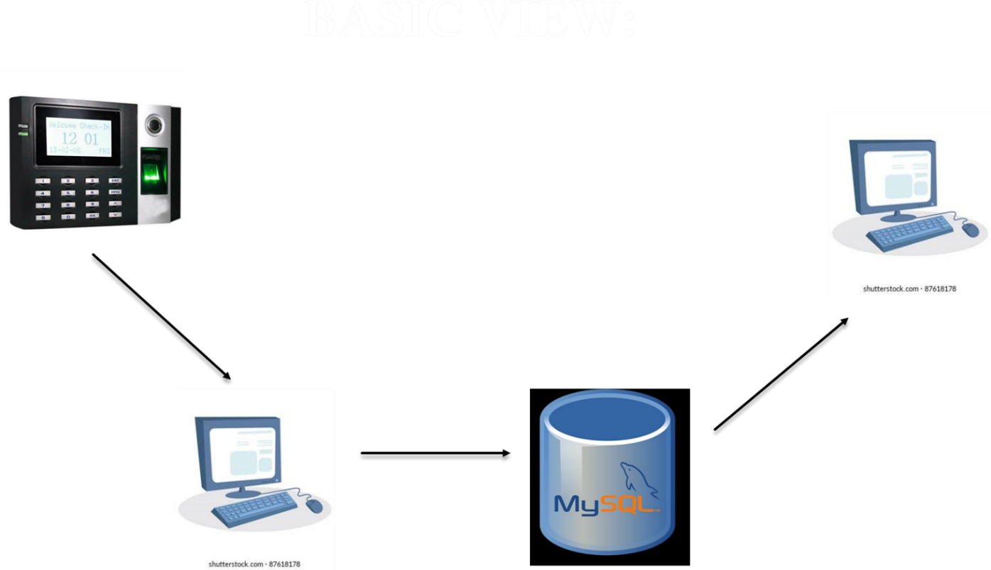

# Fig 4 Basic View

### Use Case Diagram

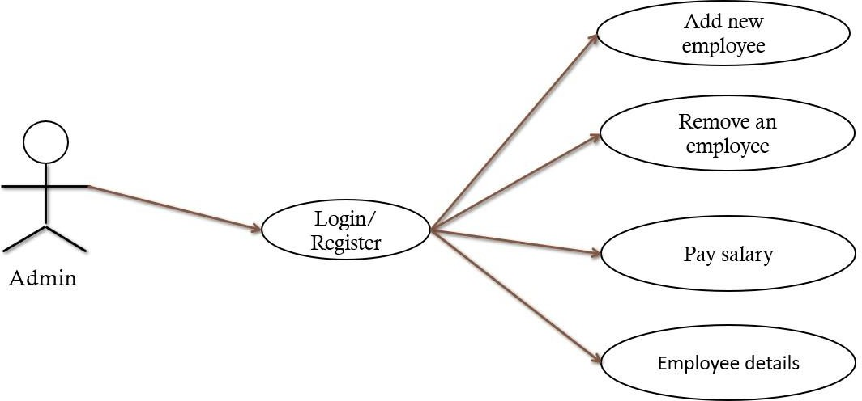

# Fig 5 Use Case Diagram

### Sequence Diagram

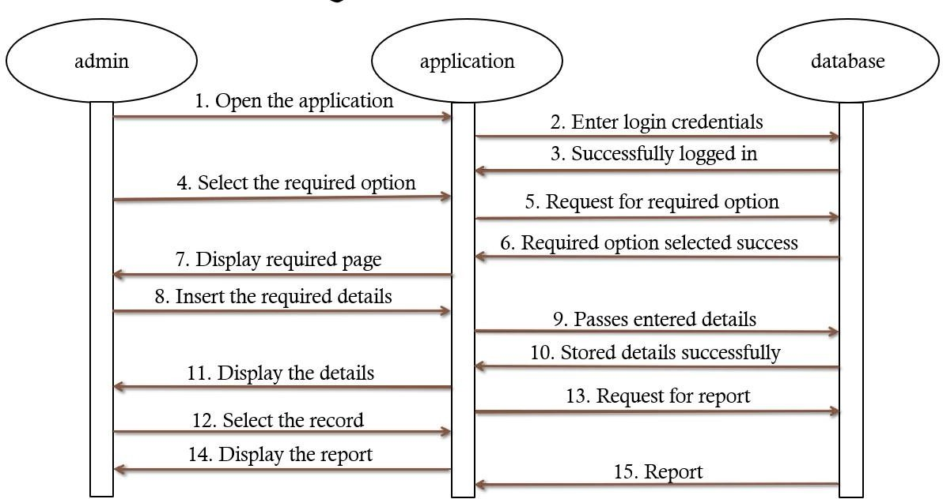

# Fig 6 Sequence Diagram

### Entity – Relationship Diagram

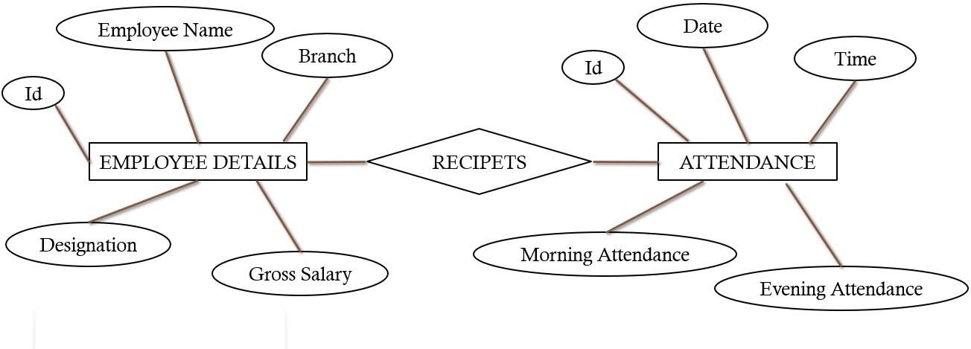

# Fig 7 Entity Relationship Diagram

**Admin**

## MODULES

The admin gets logged in by a valid username and password. Admin can add new Employees, generate payroll. Admin can set the ‘from’ and ‘to’ date worked by an employee in a department with a specific pay grade. The admin can generate an automated monthly salary for an employee.

#### Sign Up page:

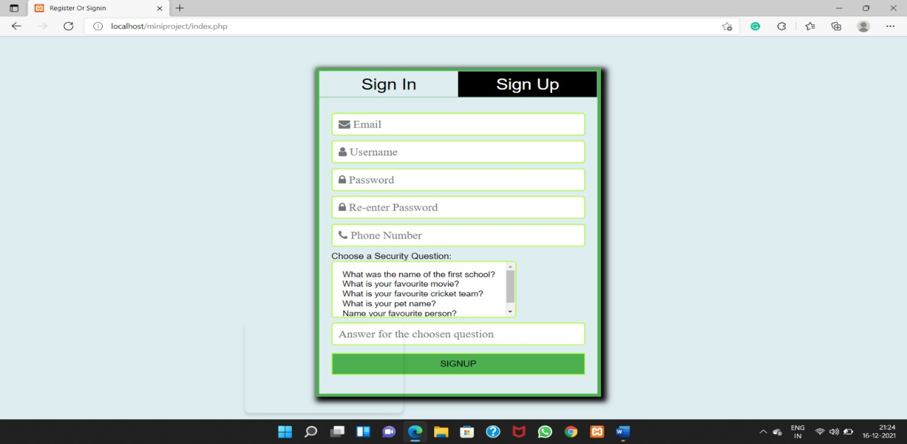

#### Sign In Page:

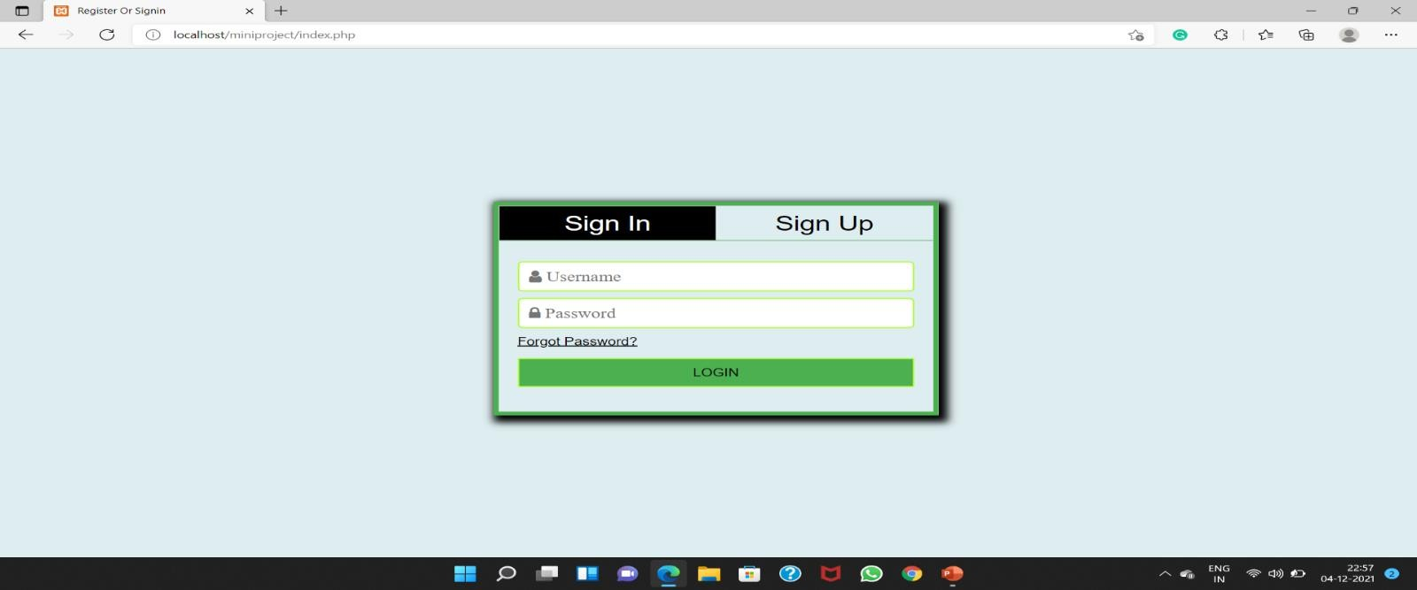

#### Homepage:

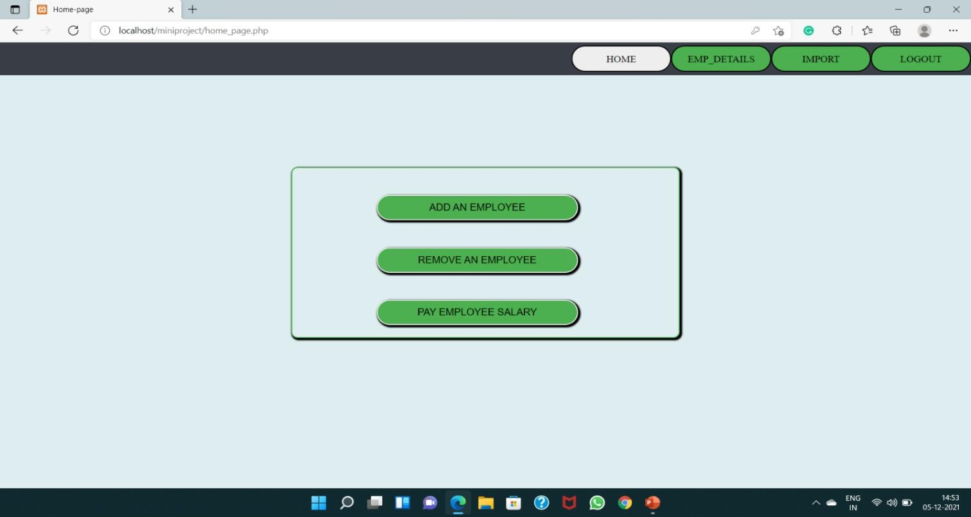

#### Employee details page:

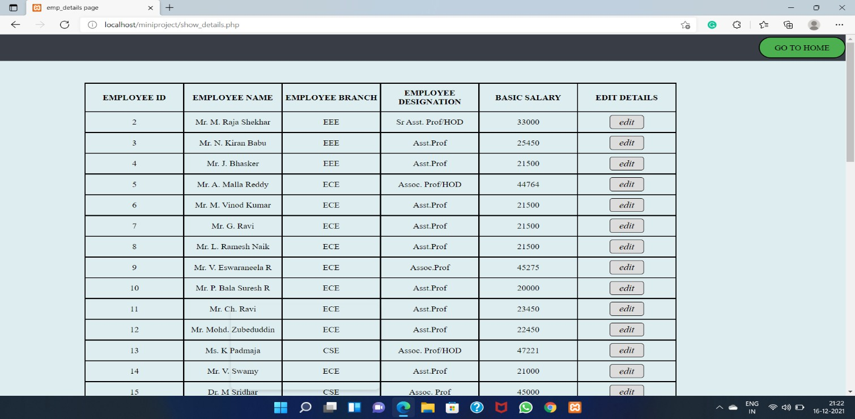

#### Update page:

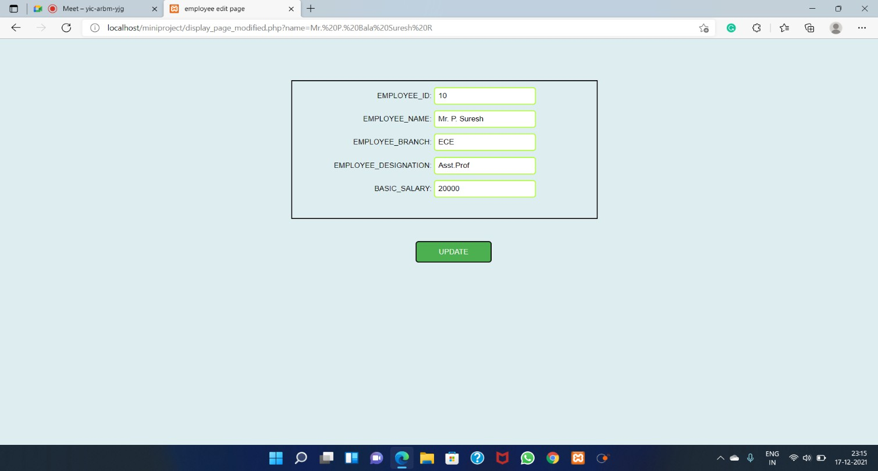

#### Importing Biometric attendance page:

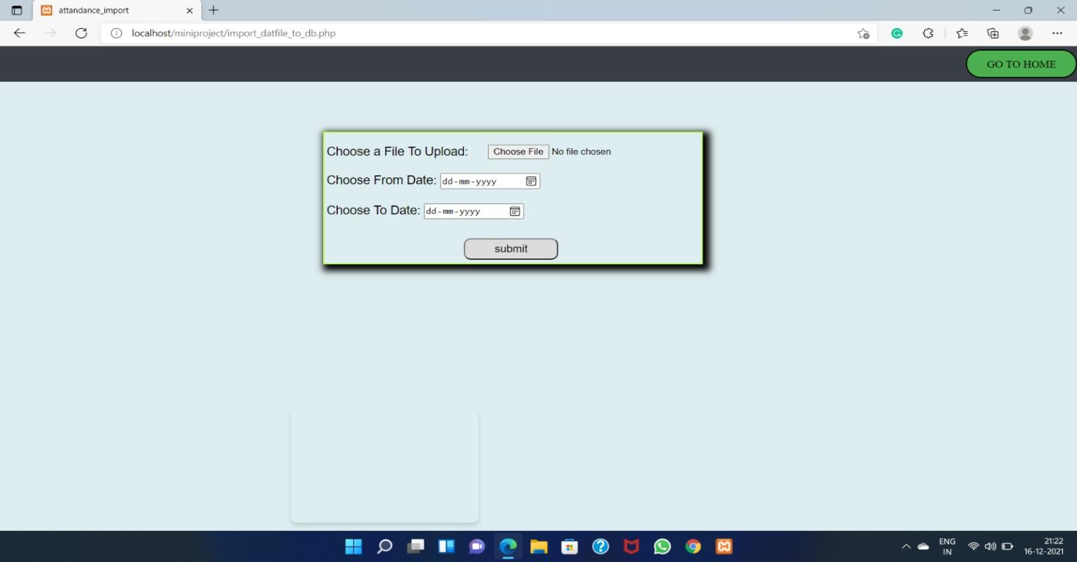

#### Add Employee Page

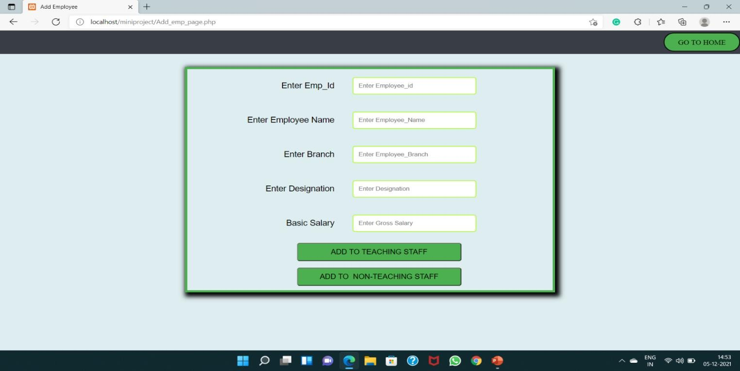

#### Remove Employee Page

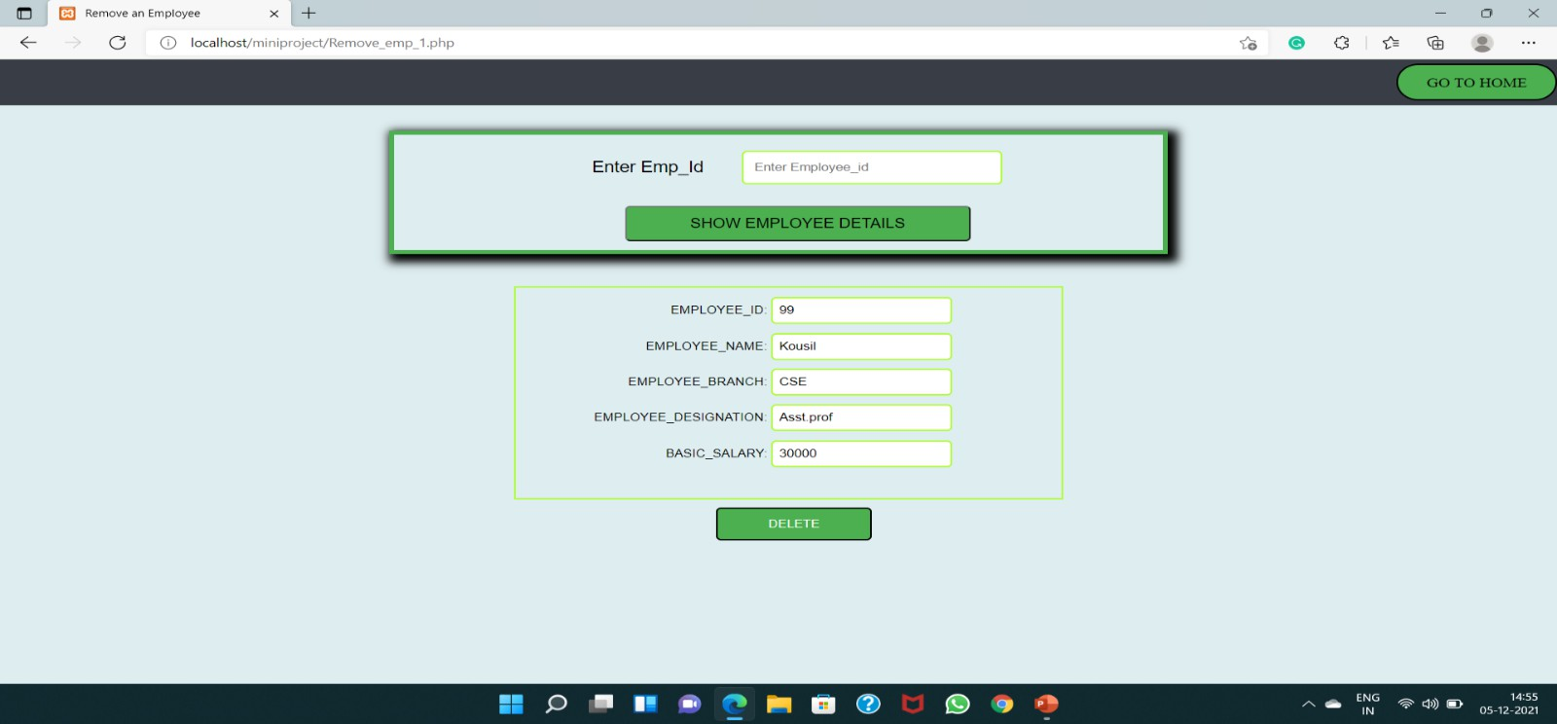

#### Pay Salary page:

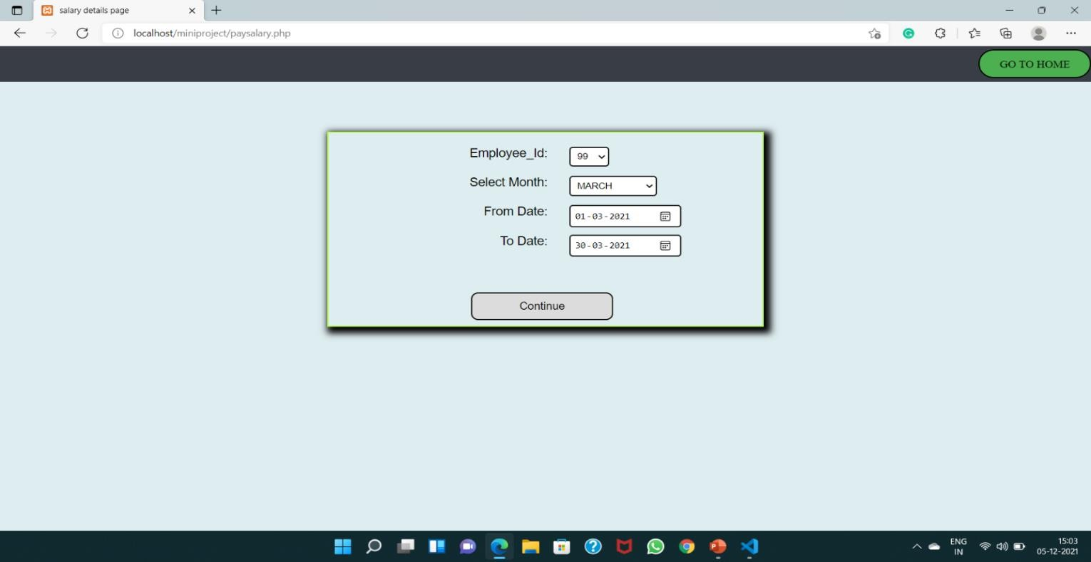

#### Salary details page:

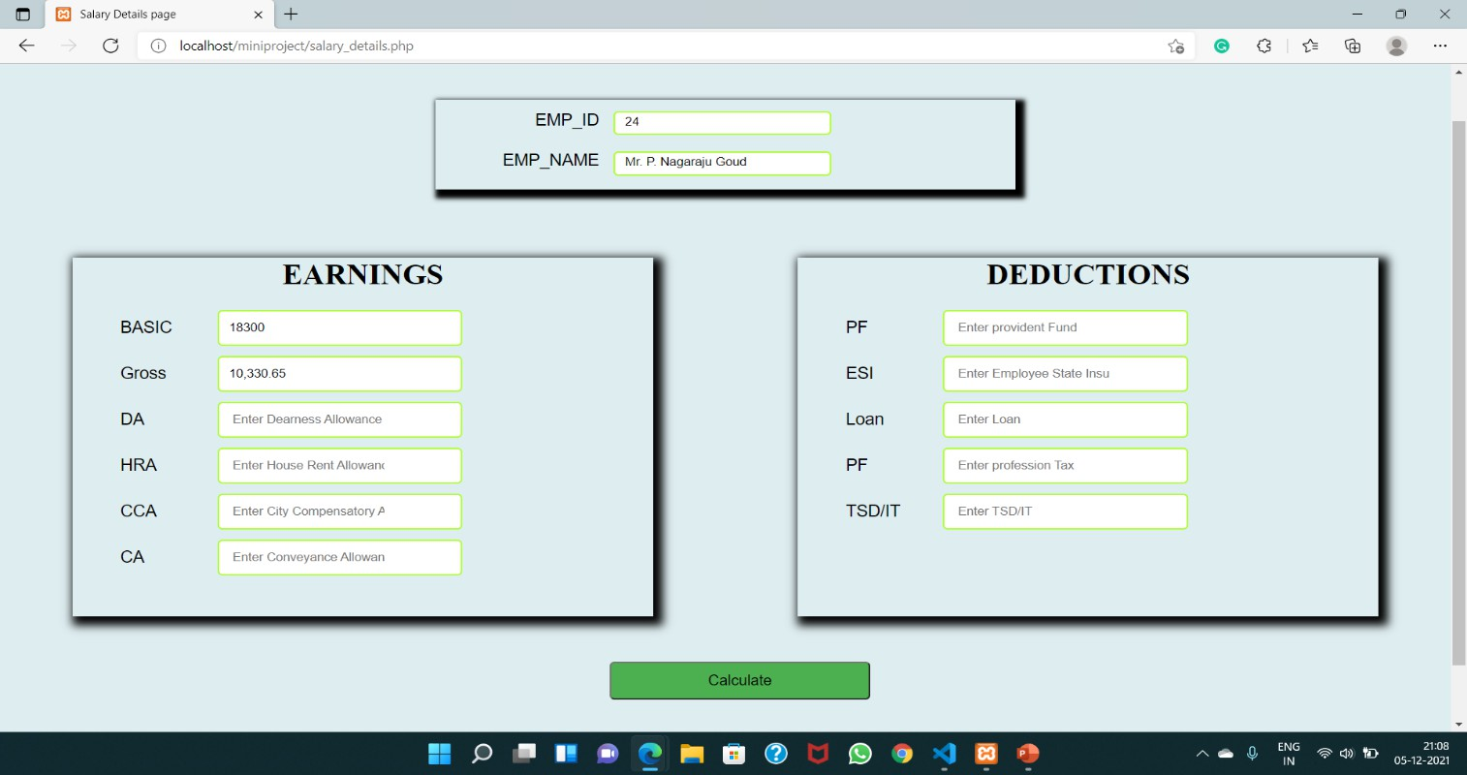

#### Pay Slip page:

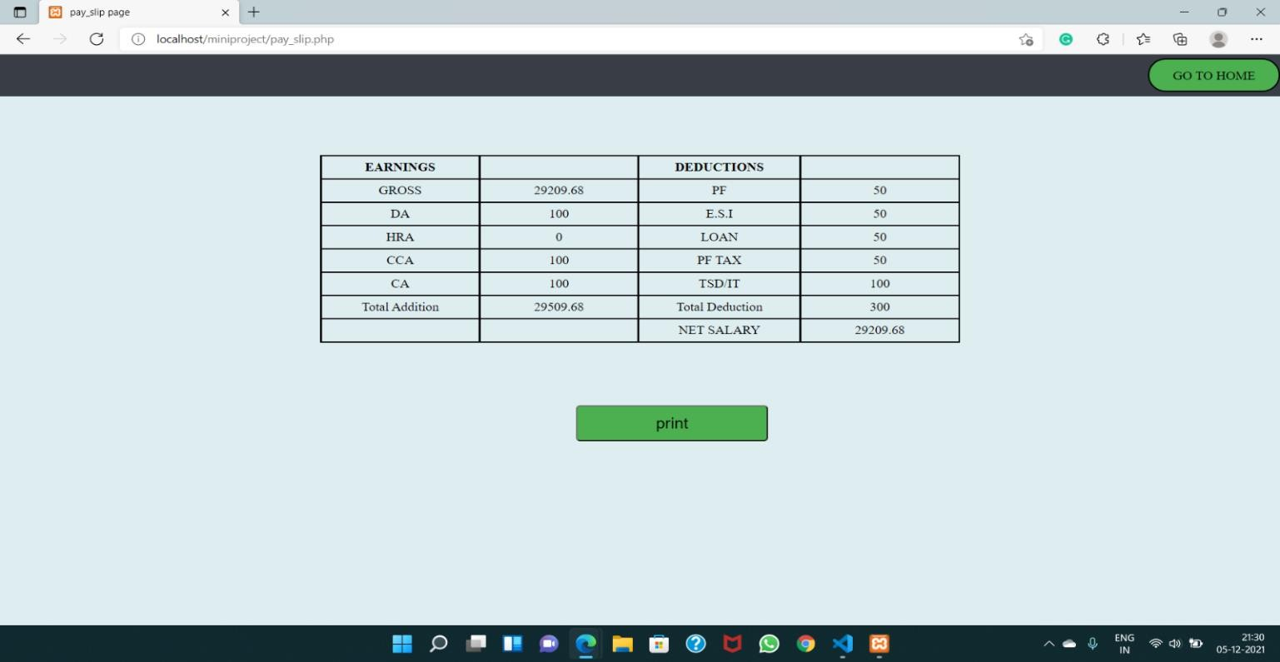

#### Forgot password page:

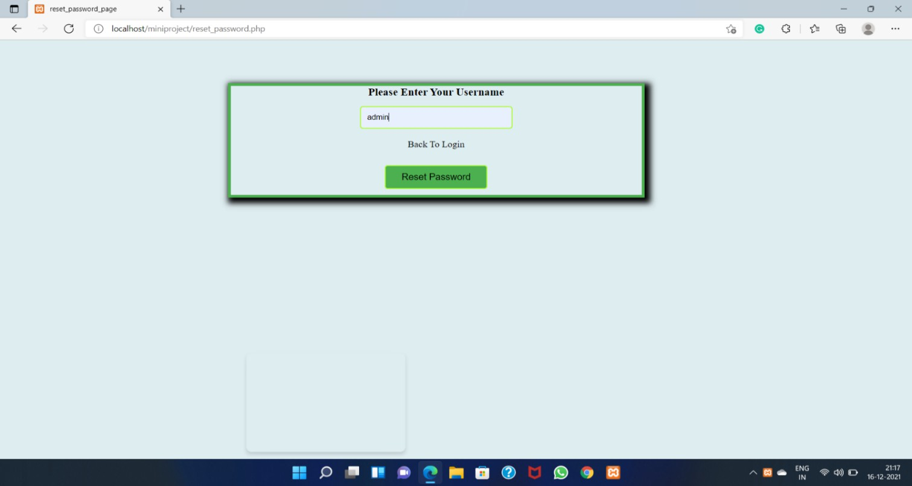

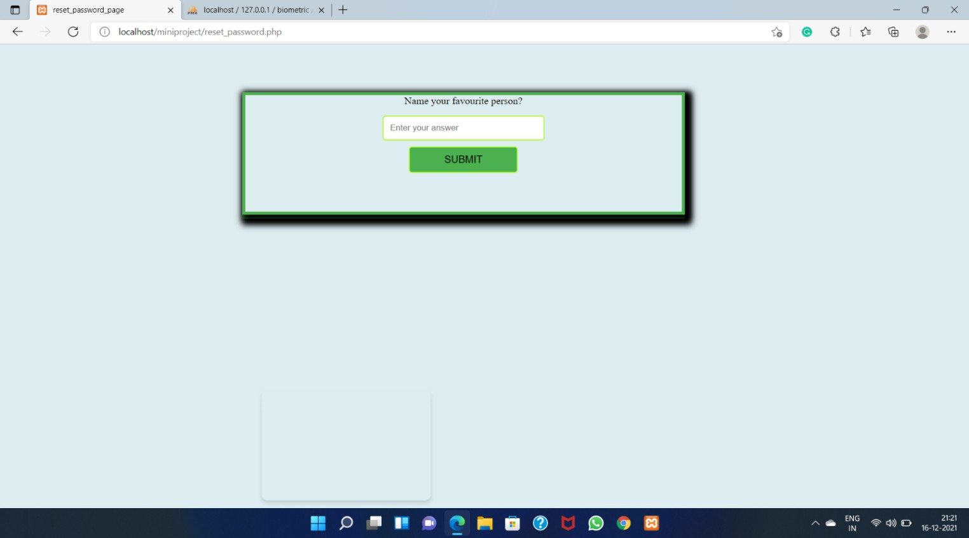

#### Reset password page:

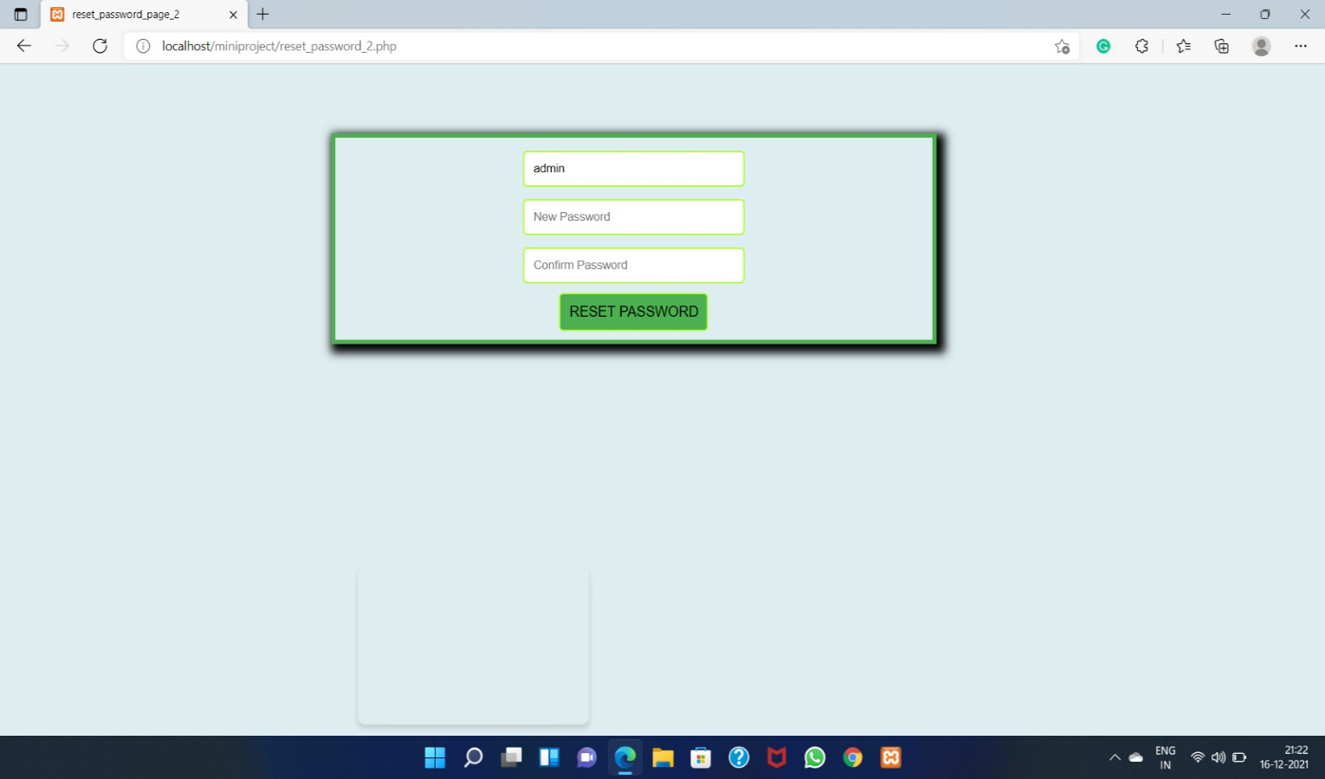

## ADVANTAGES AND DISADVANTAGES

#### Advantages:

* It is cost-effective as the user controls the web application himself and does not go for professional service.
* It saves time as it speeds up every aspect of the employee database management and payroll process with a range of automated features.
* It is secure as the employee database and the payroll process is managed by the admin in- house rather than sending private information to a third party.
* Validating procedures and checks restrict the user from making mistakes.
* The software is easy to use and is user-friendly so no expertise is required.
* The calculations are automated so no chance of error.

#### Disadvantages:

* It requires a large database when querying a large amount of data.

## CONCLUSION

* Thus “Employee Payroll management system” is designed to make the existing manual system automatic with the help of computerized equipment and full-edged computer software, fulfilling their requirements, so that their valuable data and information can be stored for a longer period with easy access and manipulation of the same.
* This web application is reduced as much as possible to avoid errors while entering data. It also provides Error messages while entering invalid data. It is user-friendly as no formal knowledge is required to use the system.
* Moreover, this system is designed for the particular need of an institution to carry out its operations smoothly and effectively.
* Finally, in our opinion, this system not only automates the process but saves the valuable time of the admin, which can be well utilized by his institute.

## BIBLIOGRAPHY

1. Web Technologies, Uttam K Roy, Oxford University Press.
2. The Complete Reference PHP – Steven Holzner, Tats McGraw-Hill.
3. Web Technologies – Kogent Learning Solutions Inc.
4. Beginning Web Programmining – Jon Duckett WROX.
5. WEBSITE reference for PHP: <https://www.w3schools.com/php/>
6. WEBSITE reference for HTML: https:/[/www.w3schools.com/html](http://www.w3schools.com/html/)/